Plans to transform a former military base into a vibrant new waterfront for Lee-on-the-Solent have been approved.
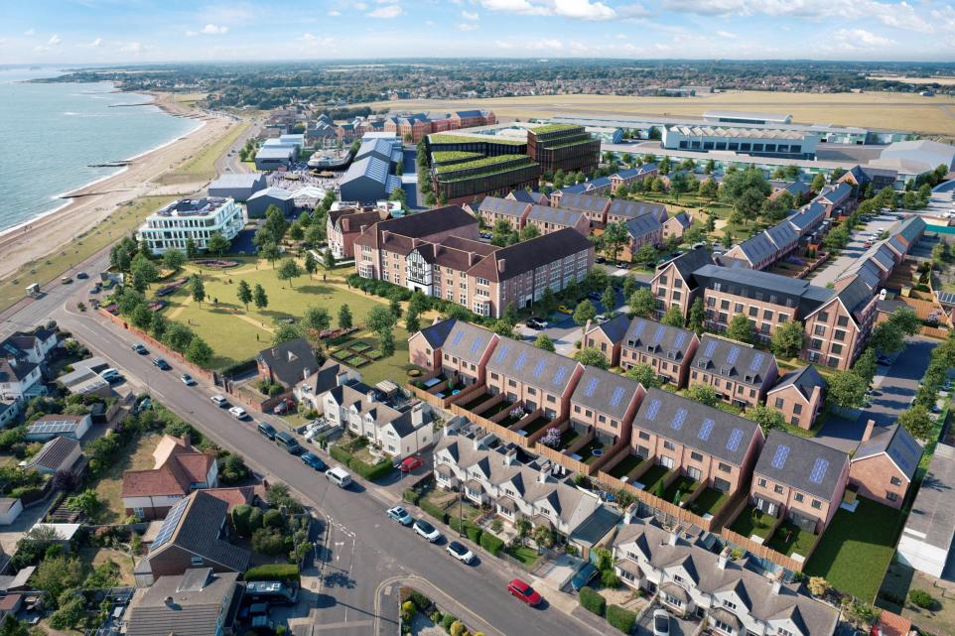
Gosport Borough councillors unanimously voted to approve the Daedalus Waterfront development.
The landmark regeneration scheme has been put forward by a joint venture between Patron Capital, MurrayTwohig Developments, and Orwell Real Estate, who were selected by Homes England as development partners for the site last year. Their proposals will boost the local economy through the creation of new commercial and leisure sector jobs, provide much needed housing, protect, and reinvigorate the various historic and listed assets, and secure the future of the largest collection of hovercraft in the world in The Hovercraft Museum.
The proposals include:
- 24,500sqm of new, modern employment and industrial space.
- 5,200sqm of commercial space for new businesses and jobs in the Solent Enterprise Zone.
- 346 new mixed-tenure homes, 76 of which will be refurbishments of the existing heritage buildings including the historic barracks square.
- New community services and facilities, including a public park.
- A world-class visitor attraction at Seaplane Square and The Hovercraft Museum.
Central to the vision is the restoration of the historic buildings, including the World War One hangars that face the Solent. These will act as a gateway to the project, an upgraded home for The Hovercraft Museum and a new public space for local events and activations.
The first two zones submitted for detailed planning will deliver key objectives of the Daedalus Waterfront: employment prospects and reassuring the heritage of the site. To the north of the site, The Evill Industrial Park (named after the first commandant of HMS Daedalus, Lieutenant Commander Strathearn Evill) will be an important catalyst for the wider development that will bring jobs and opportunities through new small, medium and mid-sized industrial units.
The residential zone will save and celebrate the heritage of the area. This will include Daedalus Square, which will see the historic barracks square restored and transformed into a quiet, communal and public space with mixed-tenure town houses, apartments and terraces. This zone will also be home to Westcliffe Gardens, a second residential zone with a large publicly accessible park and sea views. Here, the restoration and protection of historic buildings includes Westcliffe House, The Wardroom and The Gatehouse and lodge.
Speaking to the committee, councillor John Beavis said the hybrid application is the “most important” the council has determined “in a long time”. He said: "Daedalus closed in 1996 as a military establishment and since then we’ve had a number of interested developers who have come forward with completely unacceptable proposals.“I appreciate the plan will take 10 years to complete but at last on completion Daedalus will be back again as a part of our community. I’m delighted to see such an excellent proposal.”
More information can be found here:
https://daedaluswaterfront.co.uk/daedalus-waterfront-planning-approval/#:~:text=Working%20in%20close%20partnership%20with,D%2DDay%20in%20June%201944.

